**PHYS 123, Lab 2 Questions**

**Name:** Markiyan Varhola **CWID:** 20324717

*\* see attached sheet for calculations*

1. *Answer the following questions using the data you acquired in this experiment:*
   1. *What are the two initial velocities for the first two firing settings (the first two “clicks”)? Make a table consisting of the initial velocities, its components vx and vy, the launch angles, the time of flight, and the horizontal range.*

|  |  |  |  |  |  |  |
| --- | --- | --- | --- | --- | --- | --- |
| # of clicks | Launch angle | Time of flight | Horizontal Range | $V_{x}$ | $V_{y}$ | $V_{initial}$ |
| 1 | 45° | .74 s | 175 cm | 2.36 $\frac{m}{s}$ | 2.36 $\frac{m}{s}$ | **3.34 $\frac{m}{s}$** |
| 2 | 70° | 1.00 s | 152 cm | 1.52 $\frac{m}{s}$ | 4.17 | **4.44** |

* 1. *Consider the angle that gave you the longest range. What is the maximum height (ymax) reached at this angle? What is the overall maximum height reached in your experimental data? Which angle gave you the maximum height?*

**The angle that produced the maximum horizontal range was 30°. Although it was not the maximum height achieved for all angles in the experiment, the maximum height for a 30° angle is 14 cm at an initial velocity of 3.34m/s (1 click). The overall maximum height was achieved at 70°, the steepest angle in the experiment. Although, the maximum possible height for any initial velocity can be found if there is only a vertical component, hence the angle needs to be 90°.**

* 1. *Make a graph of launch angle vs. horizontal range for the second experiment. Label the axes appropriately with correct units.*

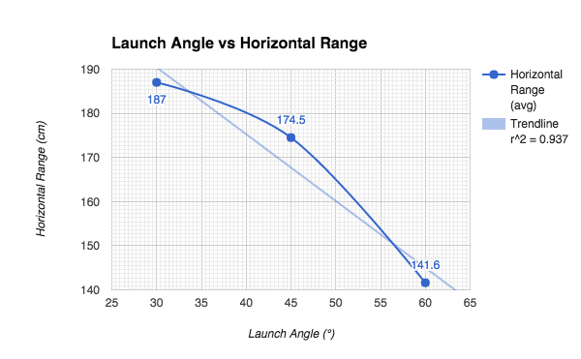

* 1. *For the third experiment, how do your measured values of the gravitational acceleration compare to the accepted value of g = 9.8 m/s2? What are possible sources of error for this experiment?*

**The calculated value for the acceleration due to gravity in the experiment was 10.03 m/s^2.**

**This value is very close to the accepted value, but due to errors such as measuring the initial launch position and the latency of the sensor, the value is not exactly the accepted value.**

* 1. *If the steel ball is shot vertically upward, how long would it take for it to hit the floor below? Calculate for both initial velocities.*

For an initial velocity of **3.34m/s (1 click)**, the time is **.91 seconds**.

For an initial velocity of **4.4m/s (2 clicks)**, the time is **1.09 seconds**.

1. *Ideally, what kind of mathematical curve is the projectile motion trajectory? Describe two examples of projectile motion which you have observed or experienced outside of this physics lab that follow this mathematical curve.*

**The curve of the projectile should be a parabola, as it most accurately describes the trajectory of motion. This trajectory can be seen by throwing a ball into the air to another person or rolling an object such as a pen off a table. The parabolic trajectory holds true for both examples.**

1. *Are there two different launch angles that would give you the same range? How about the same height? Explain.*

**There are two angles for every range and height, however their vertical and horizontal components must be such that their time of flight and their horizontal component must produce the same horizontal range. The height from launching an object at two different angles can be equal only if they are launched at the same angle from 90 degrees, for example 100 and 80 degrees, as their vertical components will be the same.**

1. *If the steel ball is shot horizontally off the table, how much time would it take the ball to hit the ground for each of the velocity settings of the launcher? Explain your answer using the equations of motion and your experimental data. How does this relate to the ball being dropped vertically from the table top to the floor below?*

**If the steel ball rolls off a table, the horizontal velocity does not come into play, therefore the vertical velocity for both situations will be the same. Since they both have the same initial vertical velocity of 0 (the balls are not shot at an angle from the horizontal), they will experience equal acceleration due to gravity.**

**For both initial velocities, the balls will take .45 seconds to drop to the ground, assuming the table height is 1 meter. The initial velocity only matters if it has a vertical component, otherwise the situation can be thought of as simply dropping a ball off a table.**